TreeSet->

\*data structure for TreeSet is Balanced tree.

\*duplication not allowed.

\*insertion order not here but sorting order preserved.

\*hetrogenous not allowed if we try then we get Run time error ClassCast Exeption.

\*allow but only once.

Four constructor->

1.TreeSet A=new TreeSet();

( D N S O)

2. TreeSet A =new TreeSet(Comprator c)

->customized sorting order.

3.TreeSer A =new TreeSet(collection c);

4.TreeSet A=new TreeSet(SortedSet A);

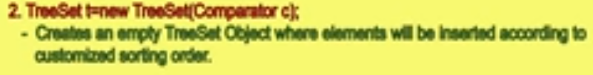

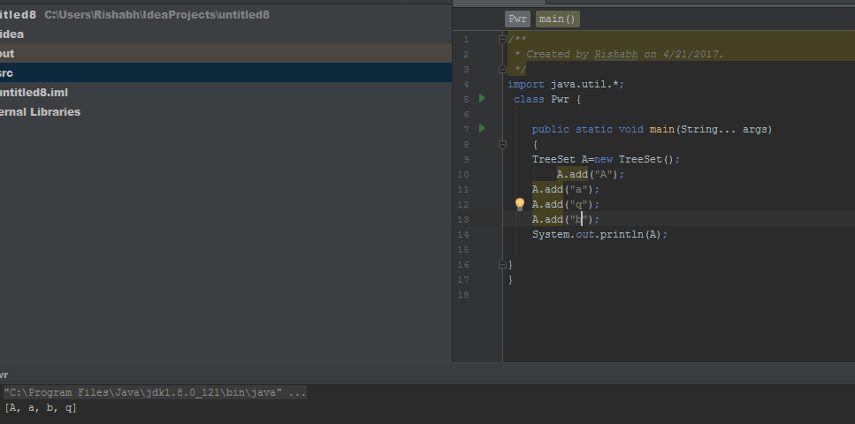

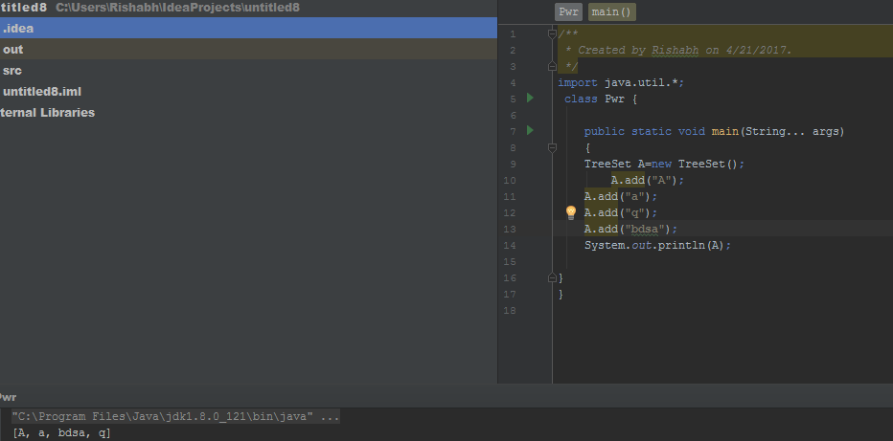

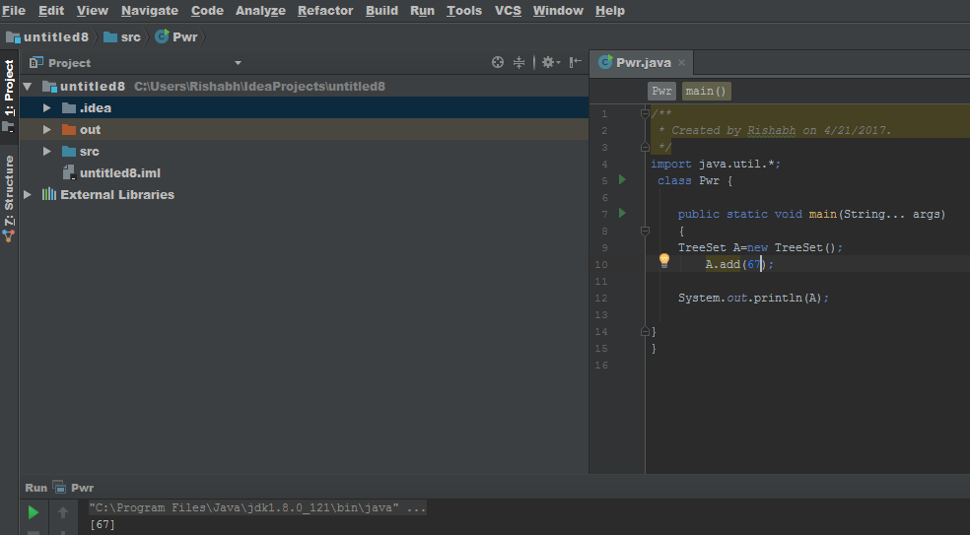

Hetro generous mtlb alg alg like integer bhi ar string bhi sb add hojana but ye hetrogenouc ni h

Get error for empty set 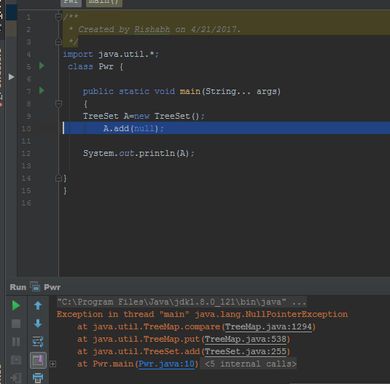

Null is not accepted.